CSA0501-DATABASE MANAGEMENT SYSTEMS
LAB EXPERIMENTS DATE: 17-08-2026

EXPERIMENT 10 - Database with VIEW and INDEX

AIM:

To create view and index on the given relation.

PROCEDURE:
- Create the employees1 table.
- Insert employee records into the table.
- Create a view v1 containing employee_id and salary.
- Display the records from the view.
- Insert and delete records through the view.
- Create an index on the salary attribute.
- Retrieve employees whose salary is above 145000.
- Drop the salary index.
- Create an index on employee_id.
- Retrieve the employee whose employee ID is 10.
- Drop the index after completing the experiment.

PROGRAM:

VIEW
1. Create a view v1 containing employee_id and salary
CREATE VIEW v1 AS
SELECT employee_id, salary
FROM employees1;

SELECT * FROM v1;
OUTPUT:
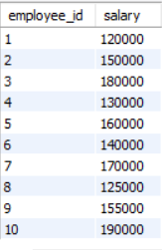

2. Insert and Delete Records from v1
INSERT INTO v1 (employee_id, salary)
VALUES (11, 145000);

SELECT * FROM v1;
OUTPUT:
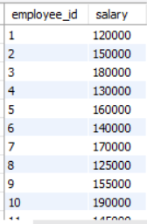

INDEX
3. Create index1 for salary
CREATE INDEX index1
ON employees1 (salary);

SELECT first_name
FROM employees1
WHERE salary > 145000;

OUTPUT:
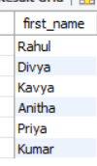

4. Create index1 for employee_id
SELECT first_name
FROM employees1
WHERE employee_id = 10;
OUTPUT:
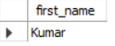

RESULT:

Thus, the view v1 was created successfully and insert/delete operations were performed. Indexes were created on the salary and employee_id attributes, records were retrieved successfully, and the indexes were dropped successfully.

